**Payroll Management System for Information Technology Company**

**Business Use-Case Specification: Delete employee**

Version 1.0

**Table of Contents**

1. Introduction

1.1. Purpose

1.2. Scope

1.3. Definition

1.4. References

1.5. Overview

2. Business Use-Case Name

2.1. Brief Description

3. Goals

4. Performance Goals

5. Workflow

5.1. Basic Workflow

6. Risk

7. Possibilities

8. Process Owner

9. Special Requirements

10. Extension Points

**Business Use-Case Specification: Delete employee**

1. **Introduction**
   1. Purpose

The purpose of this business use-case is to show how the admin delete the employee from the system.

* 1. Scope

The scope of this business use-case is associated with the Payroll management system to be deployed.

* 1. Definition, Acronyms, and Abbreviations
  2. References
  3. Overview

The rest of Business Use-Case Specificationcontains Goals, Perfomance Goals, Workflow, Risk, Possibilities, Process Owner, Special Requirements, Extension Points.

1. **Business Use-case Name**
   1. Brief Description

The use-case here is “delete”, which means in this situation the employee leaves the company and the admin delete the employees from the system.

1. **Goals**

The goal of the business use-case is to delete the employee from the system.

1. **Performance Goals**

No special.

1. **Workflow**
   1. Basic Workflow

When the admin search the employee data in the system, then send delete request to the system. The system receives the search request and show the data of the employee, then receives the delete request from the admin and delete it.

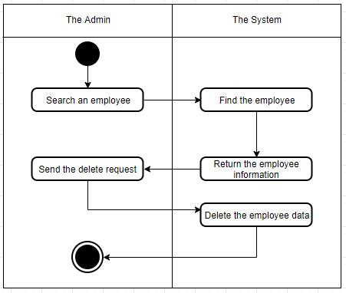

1. **Risk**

No special.

1. **Possibilities**

No special.

1. **Process Owner**

The process owner of this use-case is the admin which deals with the situation when an employee leave the company.

1. **Special Requirements**

No special.

1. **Extension Point**

No extension point.